***NAME : Himanshu Dixit***

***ENROLL NO. : B64178***

***BATCH : B10***

***SOFTWARE DEVELOPMENT FUNDAMENTAL LAB-I(15B17CI171)* *Assignment Sheet (WEEK-3 PHASE-2)***

***Lab A***

**1.** WAP to print information about yourself.

**Solution:**

#include<stdio.h>

void main()

{

printf("NAME : himanshu dixit\n");

printf("DOB : 20feburary,2002\n");

printf("MOBILE NUMBER : 9868546743\n");

}

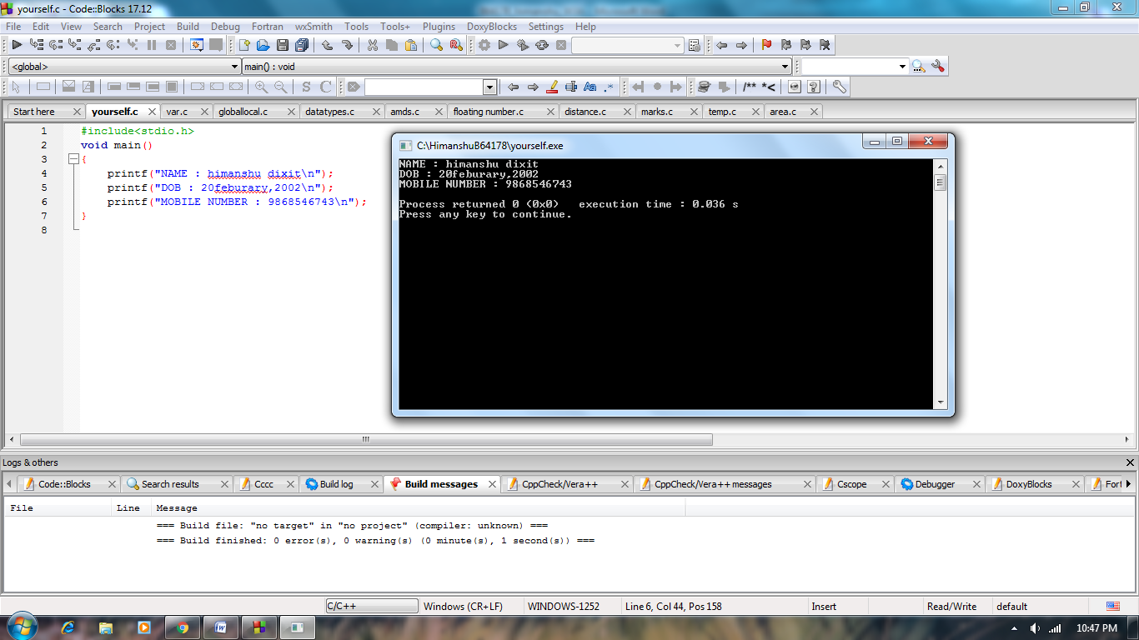

**2.** Write a program to declare two integers and one float variables then initialize them to 10, 15, and

12.6. It then prints these values on the screen.

**Solution:**

#include<stdio.h>

void main()

{

int a,b;

float c;

a=10;

b=15;

c=12.6;

printf("%d = a\n",a);

printf("%d = b\n",b);

printf("%f = c\n",c);

}

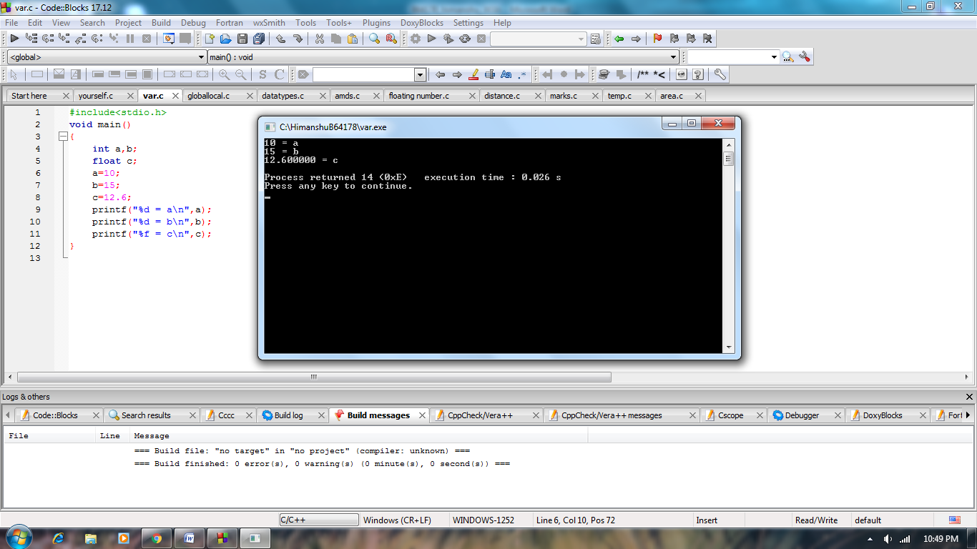

**3.** WAP to show the declaration of global and local variables.

**Solution:**

#include <stdio.h>

int x = 50; // Global x

int main()

{

int x = 10; // Local x

{

extern int x;

printf("Value of global x is %d\n", x);

}

printf("Value of local x is %d\n", x);

return 0;

}

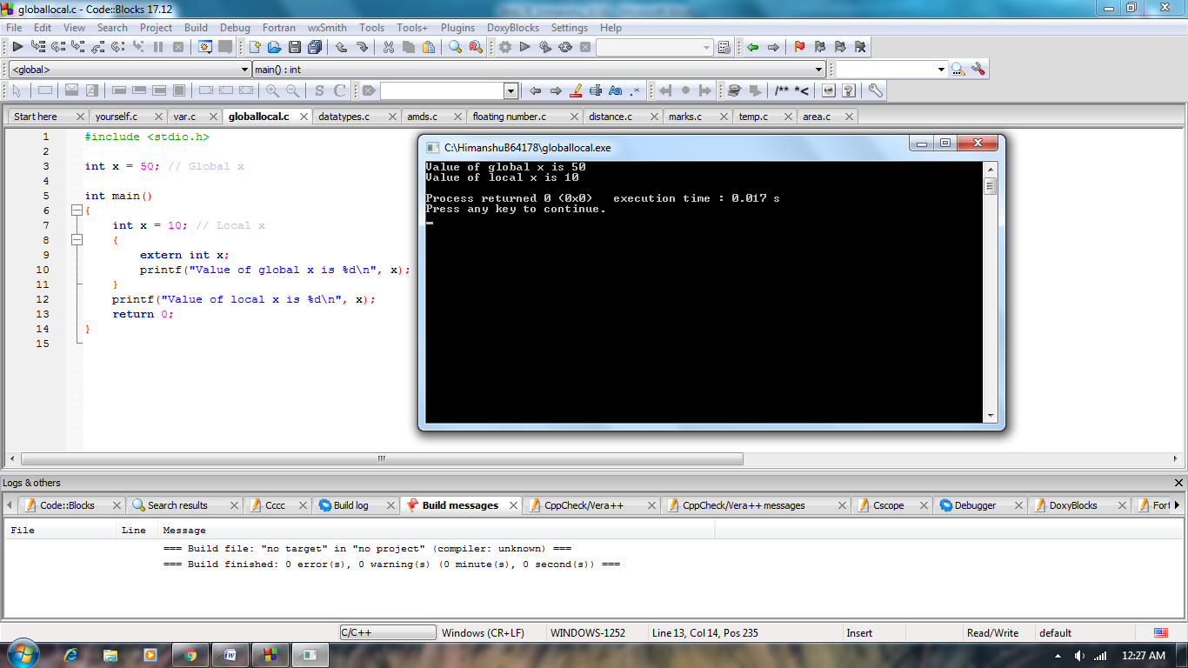

**4.** WAP to display all data types (int, float, char, double) in C.

**Solution:**

#include<stdio.h>

void main()

{

int a=10;

float b=10.50;

char c='a';

double d=10.5005;

printf("a : %d\n",a);

printf("b : %f\n",b);

printf("c : %c\n",c);

printf("d : %lf\n",d);

}

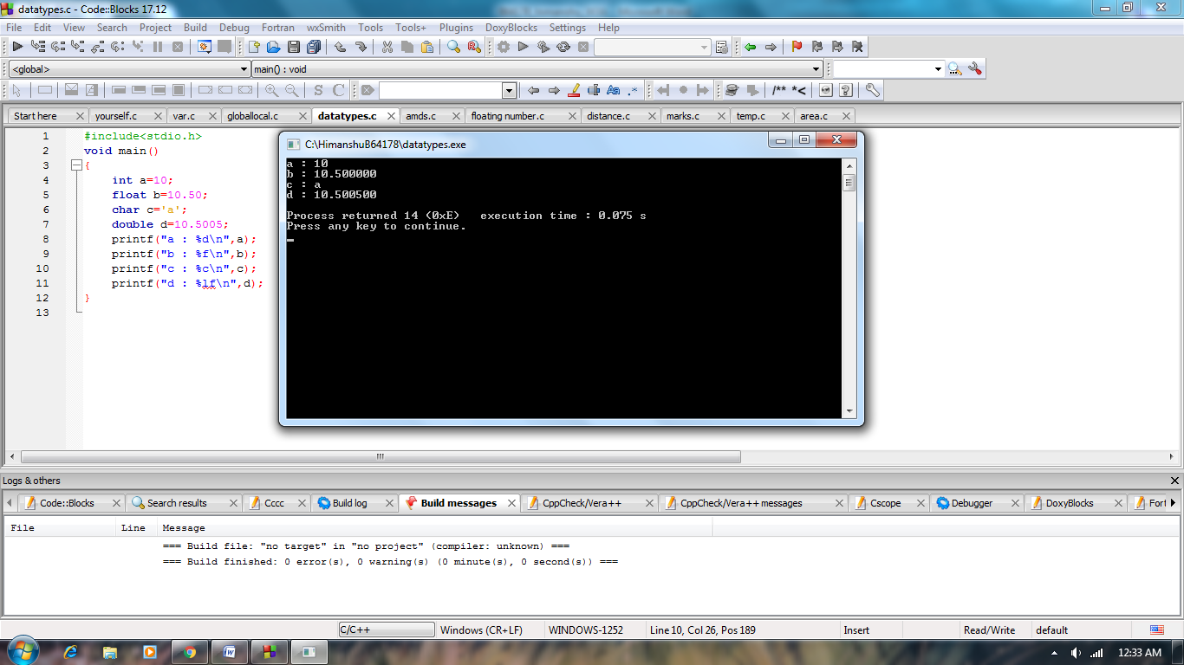

**5.** Write a program to takes input through keyboard for two integer variables and calculate their sum,

difference, multiplication & division.

**Solution:**

#include<stdio.h>

void main()

{

float a,b,sum,subtract;

float mult,div;

printf("enter two integer :");

scanf("%f%f",&a,&b);

sum=a+b;

subtract=a-b;

mult=a*b;

div=a/b;

printf("sum : %f\n",sum);

printf("subtract : %f\n",subtract);

printf("mult : %f\n",mult);

printf("div : %f\n",div);

}

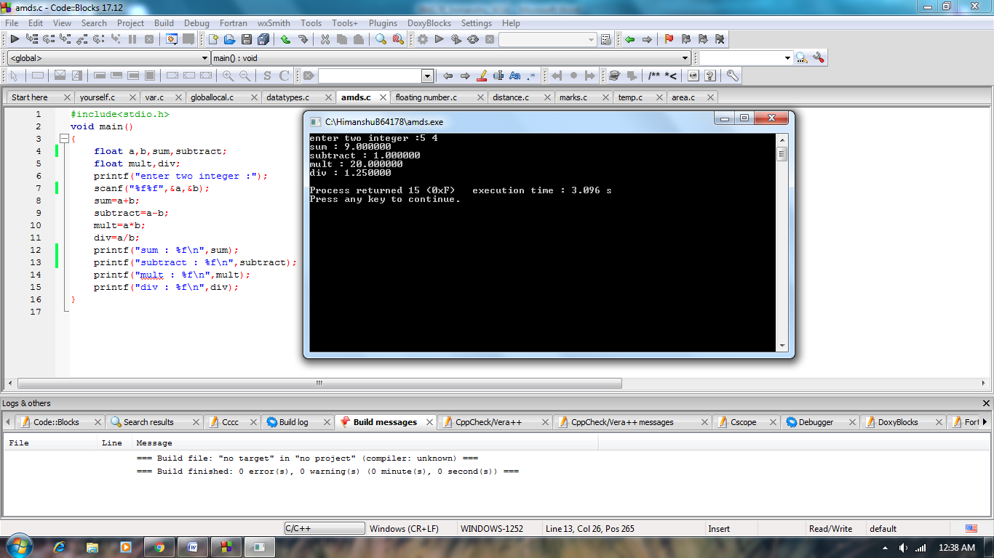

**6.** WAP to display the product of two floating point numbers.

**Solution:**

#include <stdio.h>

int main(){

float num1, num2, product;

printf("Enter first Number: ");

scanf("%f", &num1);

printf("Enter second Number: ");

scanf("%f", &num2);

product = num1 * num2;

printf("Product of entered numbers is:%f", product);

return 0;

}

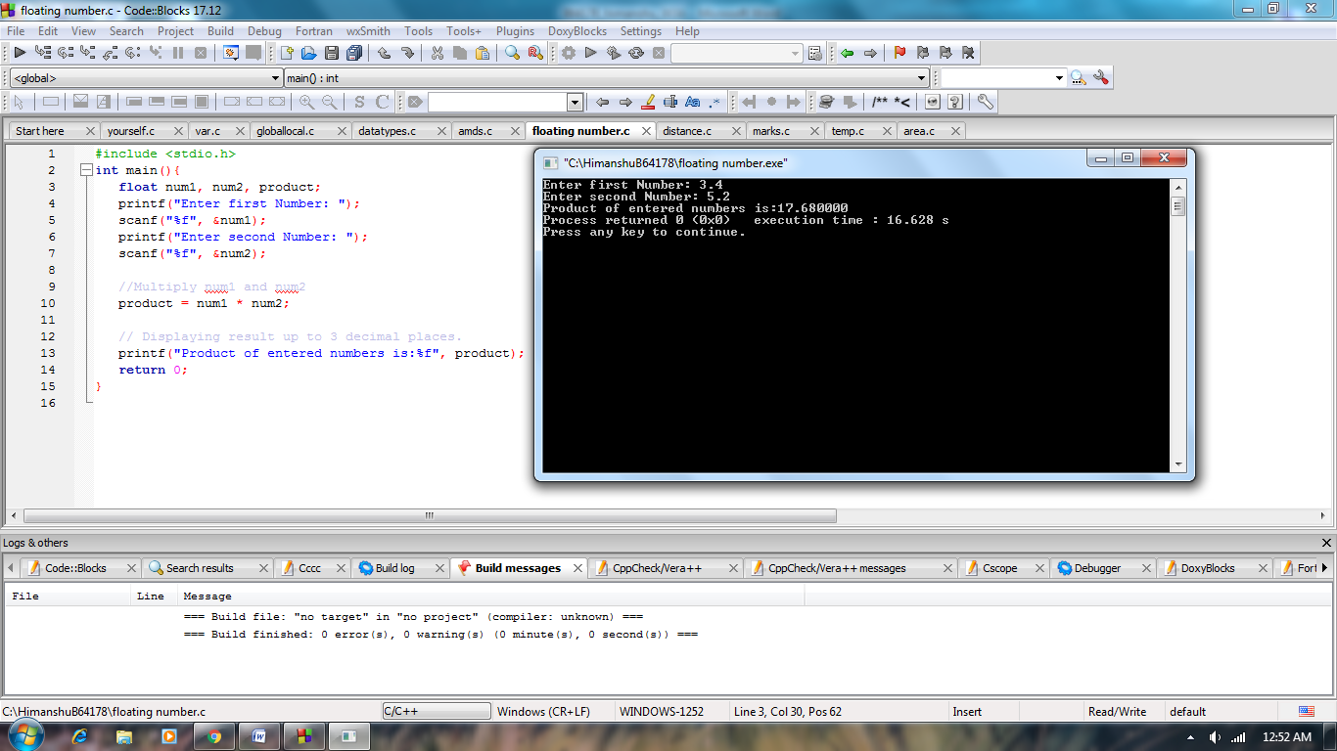

**7.** The distance between two cities (in Km) is input through the keyboard. Write a program to

convert and print this distance in meters, feet, inches and centimeters.

**Solution:**

#include <stdio.h>

int main()

{

float km,m,cm,f,inches;

printf("Enter distance in km: ");

scanf("%f", &km);

m=km*1000;

cm=km*1000*100;

f=km*3280.84;

inches=km*39370.1;

printf("the distance in m is:%f\n", m);

printf("the distance in cm is:%f\n",cm);

printf("the distance in f is:%f\n", f);

printf("the distance in inches is:%f", inches);

return 0;

}

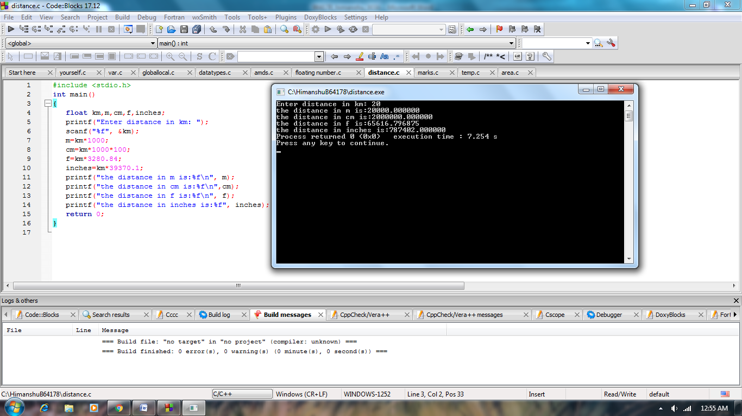

**8.** If the marks obtained by a student in five different subjects are input through the keyboard, find

out the aggregate marks and percentage marks obtained by the student. Assume maximum

marks in each subject=100.

**Solution:**

#include <stdio.h>

int main()

{

float m,h,s,e,c,tot;

float per;

printf("Enter marks in maths: ");

scanf("%f", &m);

printf("Enter marks in hindi: ");

scanf("%f", &h);

printf("Enter marks in science: ");

scanf("%f", &s);

printf("Enter marks in english: ");

scanf("%f", &e);

printf("Enter marks in computer: ");

scanf("%f", &c);

tot=m+h+s+e+c;

per=tot/5;

printf("the total marks is:%f\n", tot);

printf("the percentage is:%f%%\n",per);

return 0;

}

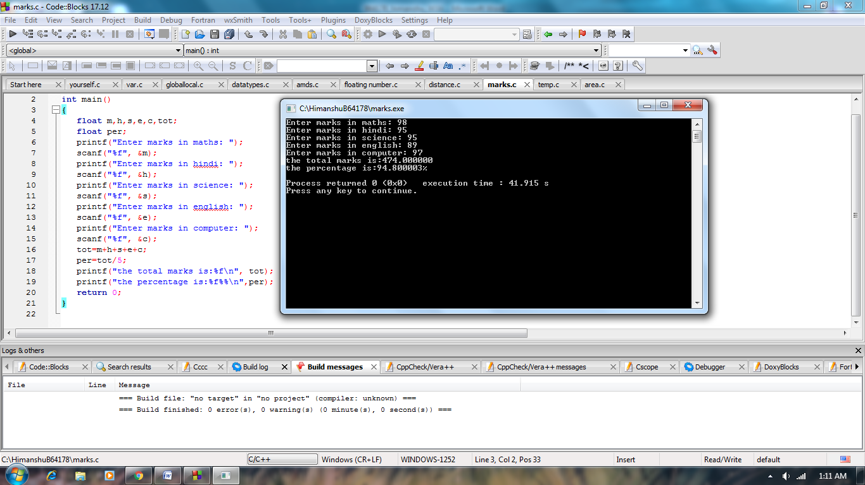

**9.** Temperature of a city in Fahrenheit degrees is input through the

keyboard. Write a program to convert this temperature into

Centigrade degrees.

**Solution:**

#include<stdio.h>

void main()

{

float f,c;

printf("enter temperature in fahrenite :");

scanf("%f",&f);

c=((f-32)*5)/9;

printf("temperature in centigrade is : %f",c);

}

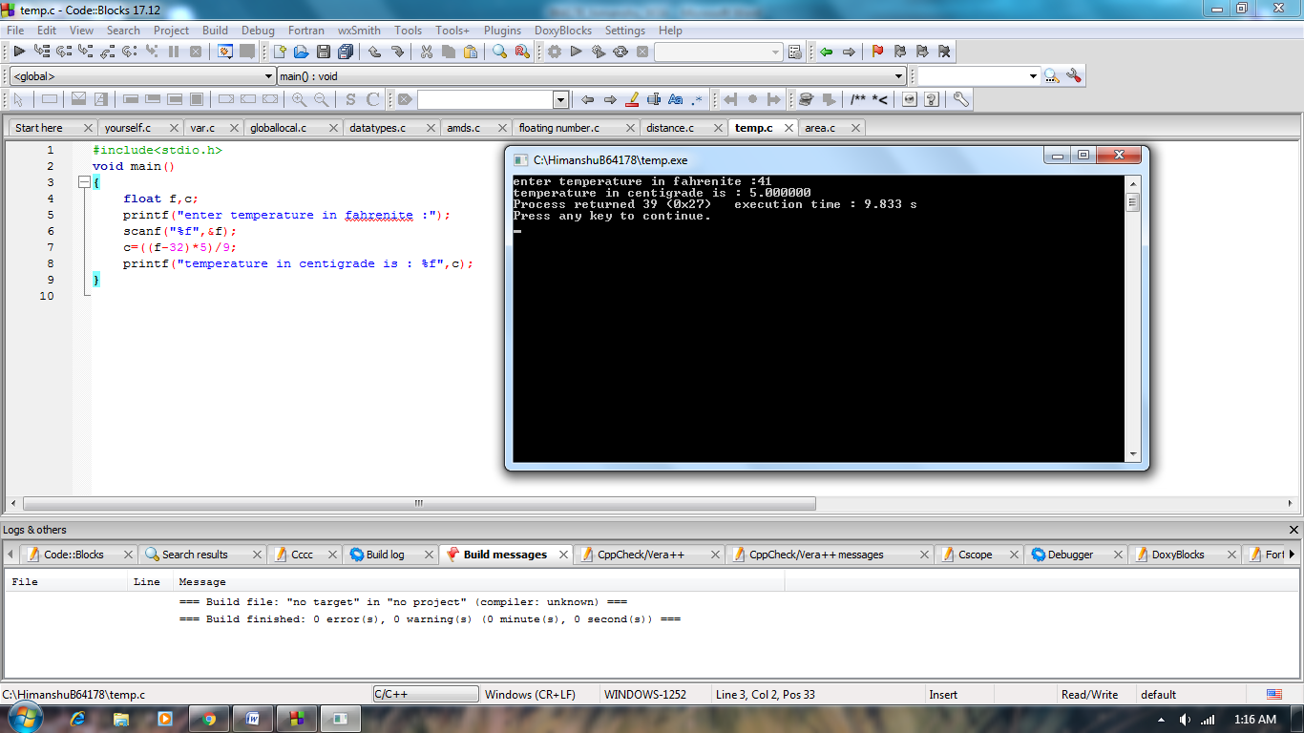

**10.** The length and breadth of a rectangle and radius of a circle are input through the keyboard. Write

a program in C to calculate the area & perimeter of the rectangle, and the area & circumference

of the circle.

**Solution:**

#include<stdio.h>

void main()

{

int length,breadth,radius;

float area_rec,perimeter,area_cir,circum;

printf("enter the length :");

scanf("%d",&length);

printf("enter the breadth :");

scanf("%d",&breadth);

printf("enter the radius :");

scanf("%d",&radius);

area_rec=length*breadth;

perimeter=2*(length+breadth);

area_cir=3.14*radius*radius;

circum=2*3.14*radius;

printf("area of rectangle :%f\n",area_rec);

printf("perimeter of rectangle :%f\n",perimeter);

printf("area of circle :%f\n",area_cir);

printf("circumference of circle :%f",circum);

}

